# CS 255 System Design Document

## UML Diagrams

### UML Use Case Diagram

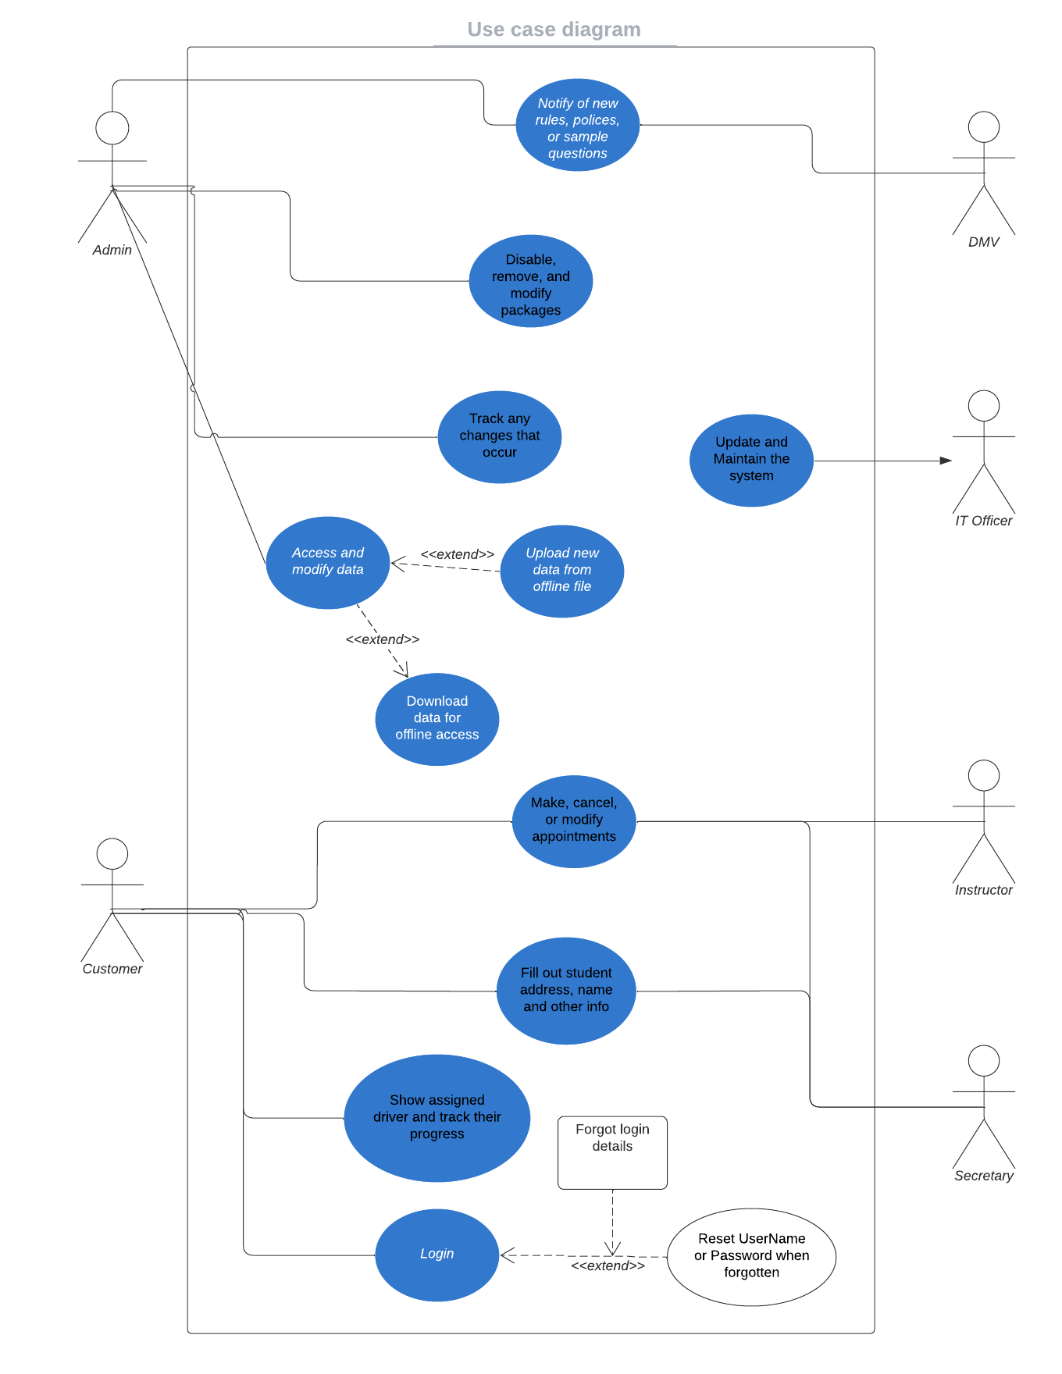

### UML Activity Diagrams

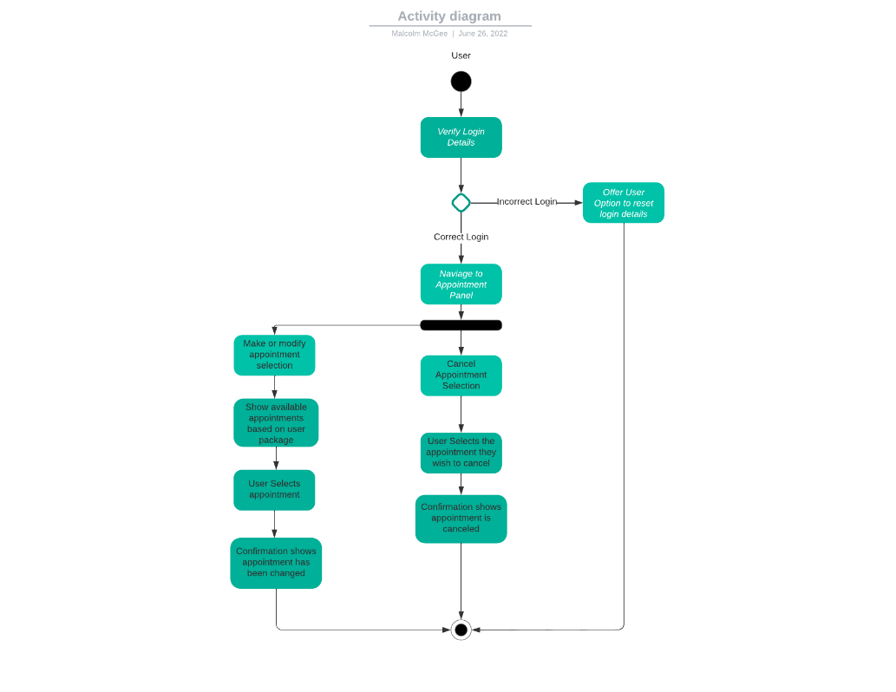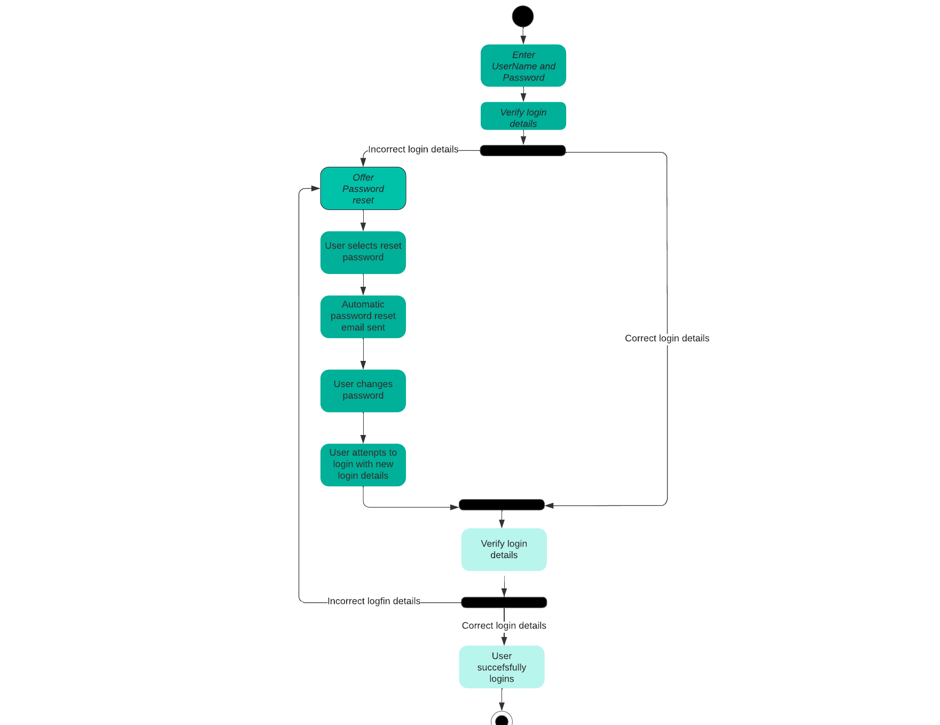

### UML Sequence Diagram

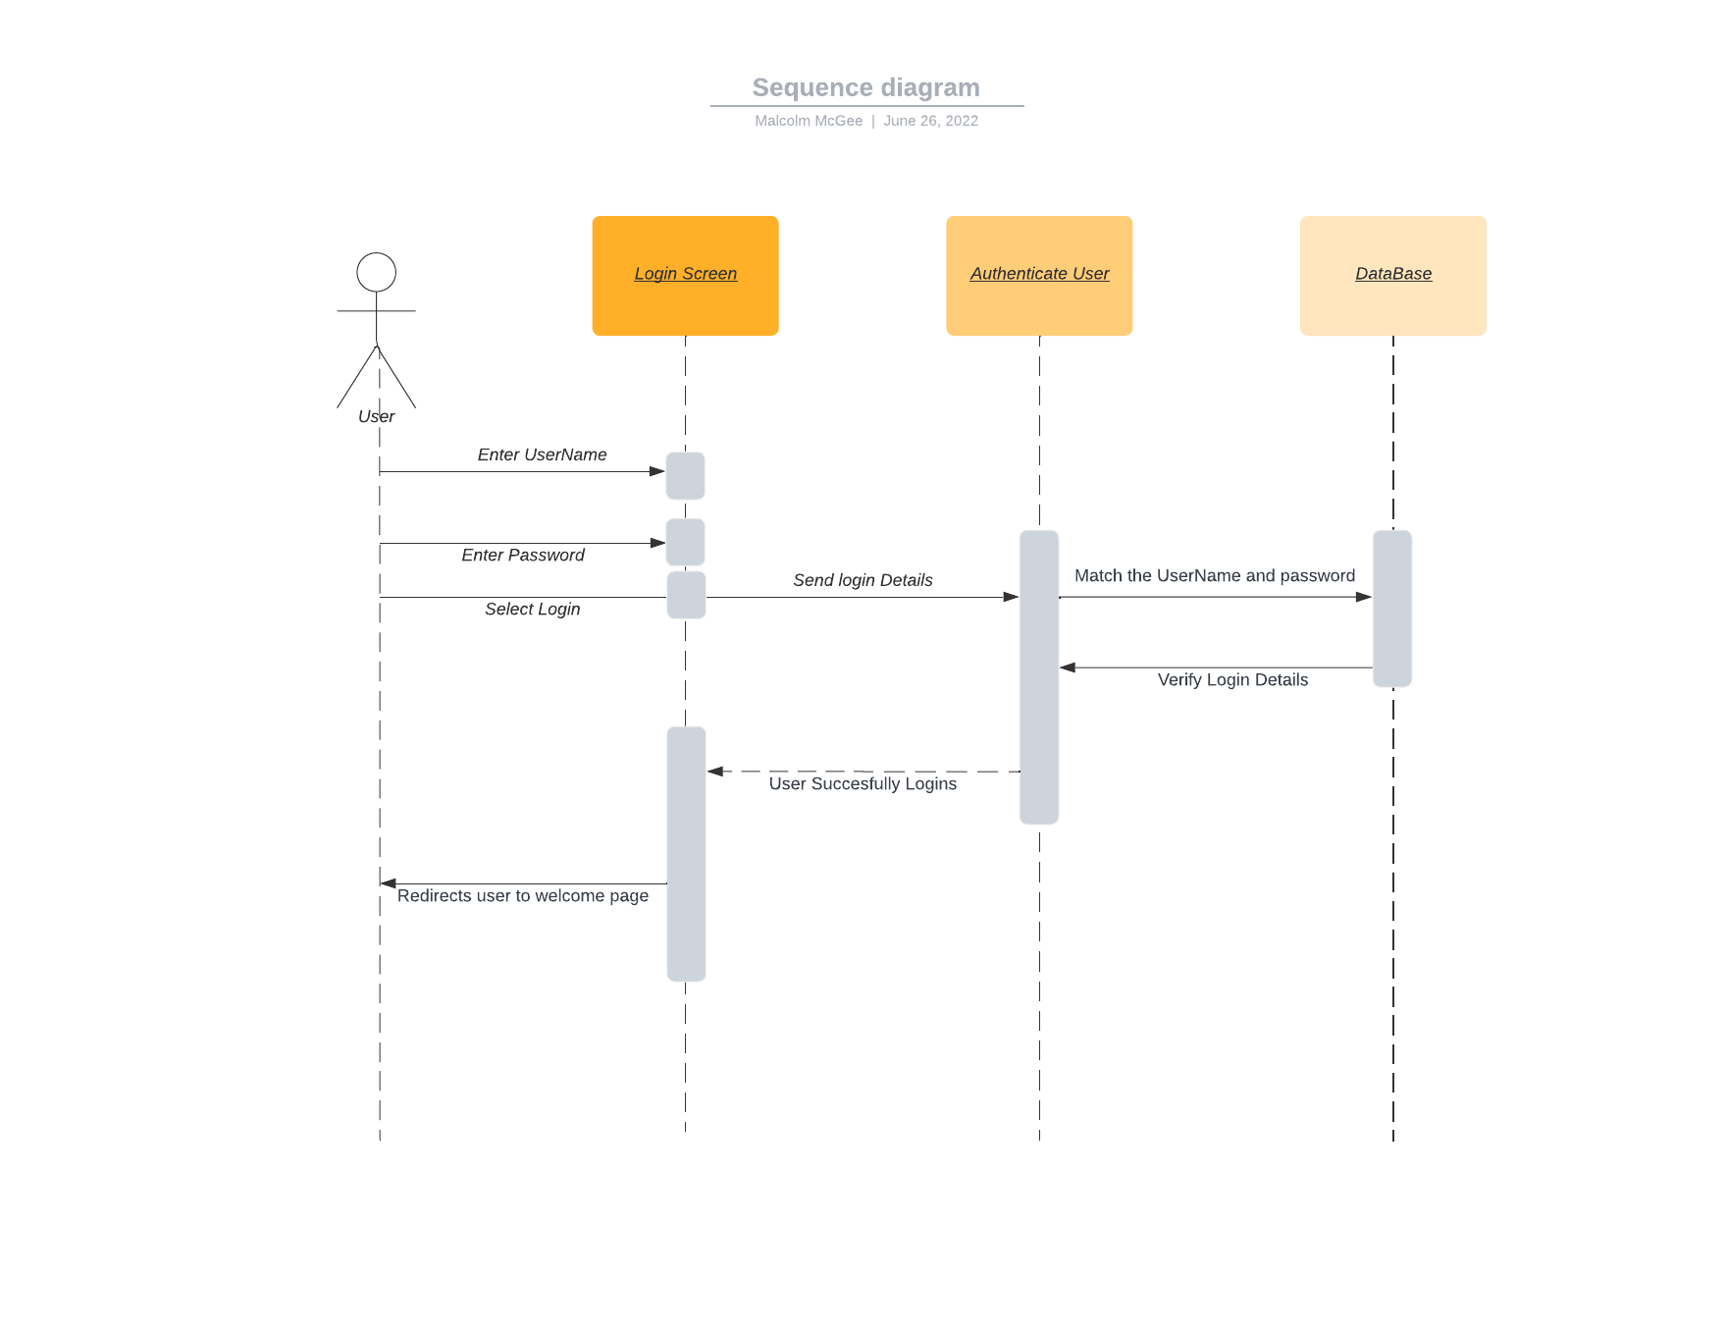

### UML Class Diagram

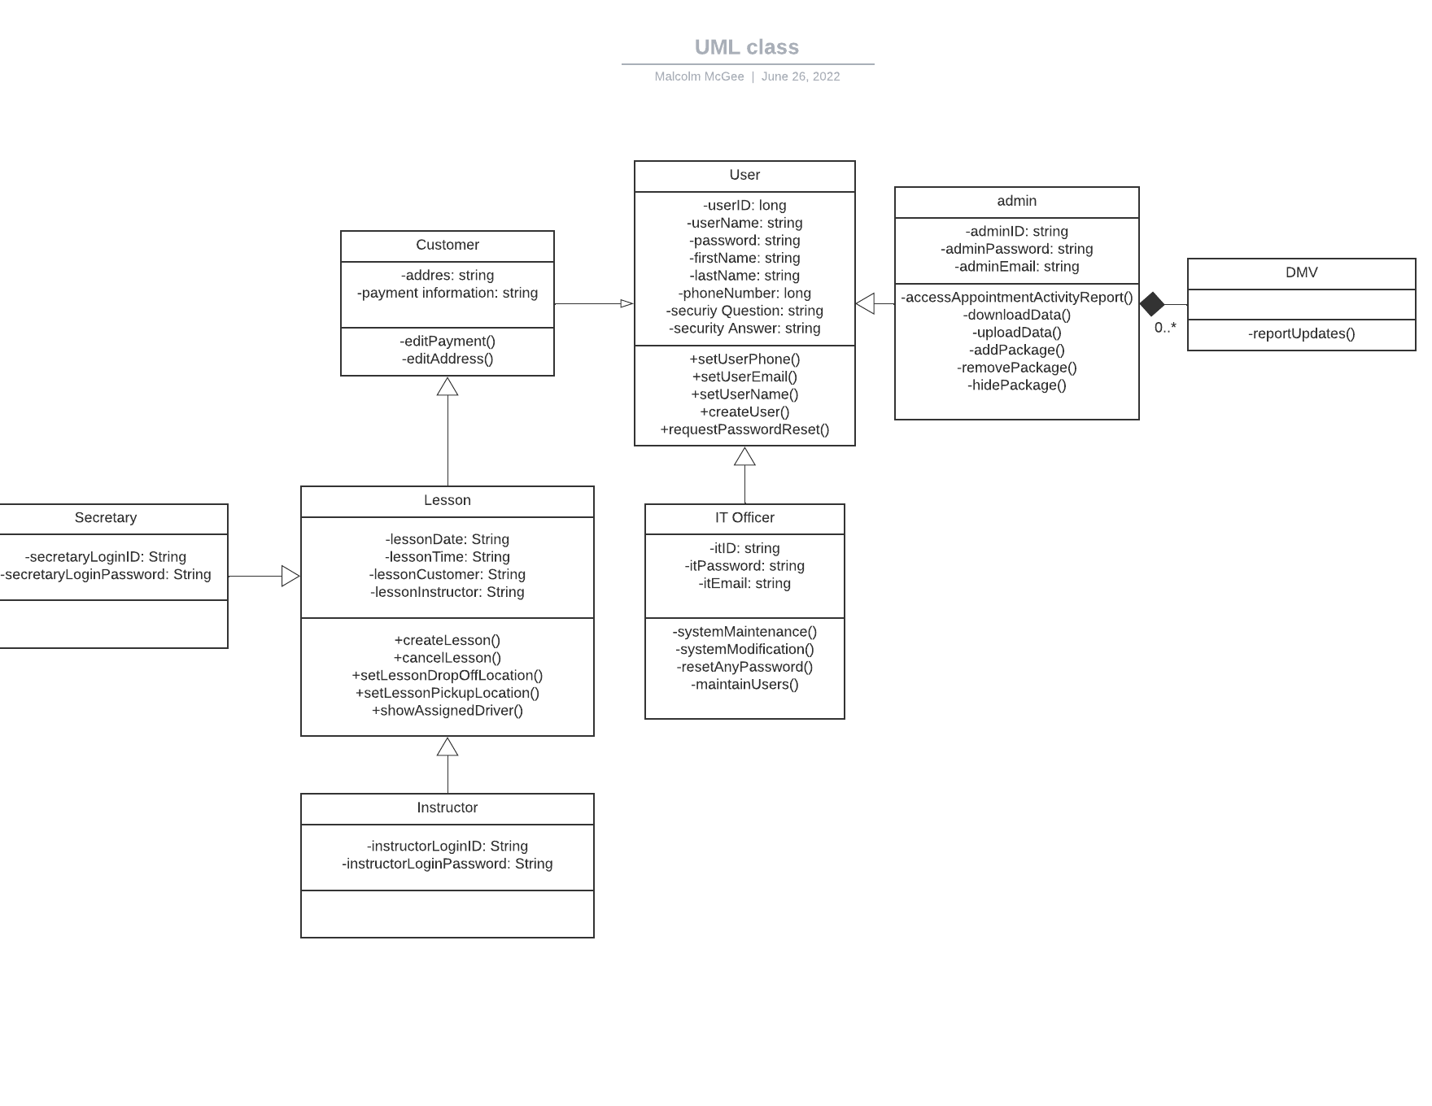

## Technical Requirements

When we look at the technical requirements for our system, we see that there are some things we need to account for. The first thing is that this must be a web-based application where the user is accessing the database. Next, we need to store the login information inside of the database and we need some type of encryption for accessing the data and logging in. With us using a cloud-based platform we can have a lower requirement for hardware. The user will need to have access to an internet connection to utilize the application and we need the option to download and upload data to the website so the admin can modify files offline. We need to have an option to check the data and see any changes in the history as well. We also need to implement role-based access so that the admin is the one that can download the files and not all the users. Same with things the IT officer or instructor would only be using.